ELECTRONIC SUPPLEMENTARY MATERIAL

Heterochromatin evolution in Arachis investigated through genome-wide analysis of repetitive DNA

Sergio S Samoluk^{1*}, Laura Chalup¹, Carolina Chavarro², Germán Robledo^{1,3}, David J Bertioli², Scott A Jackson², Guillermo Seijo^{1,3}

¹ Instituto de Botánica del Nordeste (UNNE-CONICET), Facultad de Ciencias Agrarias, Corrientes, Argentina.
² Center for Applied Genetic Technologies, University of Georgia, Athens, Georgia, USA.
³ Facultad de Ciencias Exactas y Naturales y Agrimensura Universidad Nacional del Nordeste, Corrientes, Argentina.

Email addresses:
Sergio S Samoluk (*corresponding autor): samocarp31@gmail.com; samocarp@hotmail.com
Laura MI Chalup: laura_cien@hotmail.com
Carolina Chavarro: mcch@uga.edu
Germán Robledo: germanrobledo71@gmail.com
David Bertioli: bertioli@uga.edu
Scott A Jackson: sjackson@uga.edu
Guillermo Seijo: jgseijo@yahoo.com

Suppl. Table S1: Genomic composition (expressed as percentage) of class I and class II transposable elements (TEs) in A. glandulifera. The classification in the different families of TEs was based on repetitive sequences already annotated for Arachis species (PeanutBase).

REPETITIVE SEQUENCE | ORDER | SUPERFAMILY | LINEAGE/CLASS | SIMILARITY BASED ANNOTATION (CUSTOM DATABASE) | %
RETROTRANSPOSONS | LTR | TY3-GYPSY | ATHILA | EROS/*ERIS | 0.55
 |  |  |  | FIDEL/*FERAL | 15.36
 |  |  |  | PIPOKA/*PIPA | 14.29
 |  |  |  | SIVERIO/*SILVIA/*SILVER | 0.64
 |  |  | CHROMOVIRUS | LIMA | 0.12
 |  |  |  | MEDUSA/*MUSA | 0.35
 |  |  | OGRE-TAT | APOLO/*POLO | 3.42
 |  |  |  | DOROS/*DURAN/*DAN | 0.05
 |  |  |  | GRILO/*GILO | 0.43
 |  |  |  | HERMES | 0.05
 |  |  |  | MICO | 0.73
 |  |  |  | SATURNO | 0.10
 |  |  |  | SOFI | 0.04
 |  |  | UNCLASSIFIED | *ATHENA | 0.44
 |  |  |  | *CURU/*BRAVO/*GOLF/*HEMERA/*HERA | 3.34
 |  |  |  | DELTA/*CHARLIE | 0.02
 |  |  |  | *GORDO | 6.09
 |  |  |  | *LULU | 0.01
 |  |  |  | *MAIA | 0.01
 |  | TY1-COPIA | ALE | JOKA | 0.01
 |  |  |  | JULIETT | 0.01
 |  |  |  | VENON | 0.04
 |  |  |  | ZOE/ZIA | 0.21
 |  |  | BIANCA | MATITA | 0.62
 |  |  | IKEROS | BELA | 0.47
 |  |  | SIRE | RE128 | 2.20
 |  |  | TAR |  | 0.10
 |  |  | TORK | DIVA | 0.03
 |  |  |  | TALITA | 0.06
 |  |  |  | YARA | 0.11
 |  |  |  | YURI | 0.12
 |  | UNCLASSIFIED |  | NEMESIS | 0.03
 |  | PARARETROVIRUS | PARARETROVIRUS | PARARETROVIRUS | 0.67
 |  | TRIM |  | TRIM | 0.25
 | NON-LTR | LINE |  |  | 1.28
 |  | SINE |  |  | 0.04
DNA TRANSPOSONS |  | TIR | CACTA |  | 0.53
 |  |  | HARBINGER |  | 0.16
 |  |  | HAT |  | 0.22
 |  |  | MULE |  | 0.86
 |  | HELITRON | HELITRON |  | 0.11

Suppl. Table S2: Genome proportions of the main classes of TEs in A. glandulifera compared with those previously published in A. duranensis and A. ipaënsis.

TEs |  |  | A. glandulifera | A. duranensis |  | A. ipaënsis
 |  |  | (this work) | Bertioli et al. (2016) | Chen et al. (2016) | Bertioli et al. (2016) | Lu et al. (2018)
RETROTRANSPOSONS |  |  | 52.31 | 52.65 | 41.34 | 57.58 | 66.68
 | LTR |  | 50.97 | 44.74 | 40.07 | 45.72 | 64.15
 |  | TY3-GYPSY | 46.04 | 18.14 | 36.90 | 1.86 | 53.76
 |  | TY1-COPIA | 3.98 | 3.17 | 2.68 | 2.98 | 6.17
 | LINEs |  | 1.28 | 7.77 | 1.26 | 11.73 | 2.97
 | SINEs |  | 0.04 | 0.14 | 0.01 | 0.13 | 0.05
DNA TRANSPOSONS |  |  | 1.88 | 8.80 | 5.19 | 10.73 | 6.64

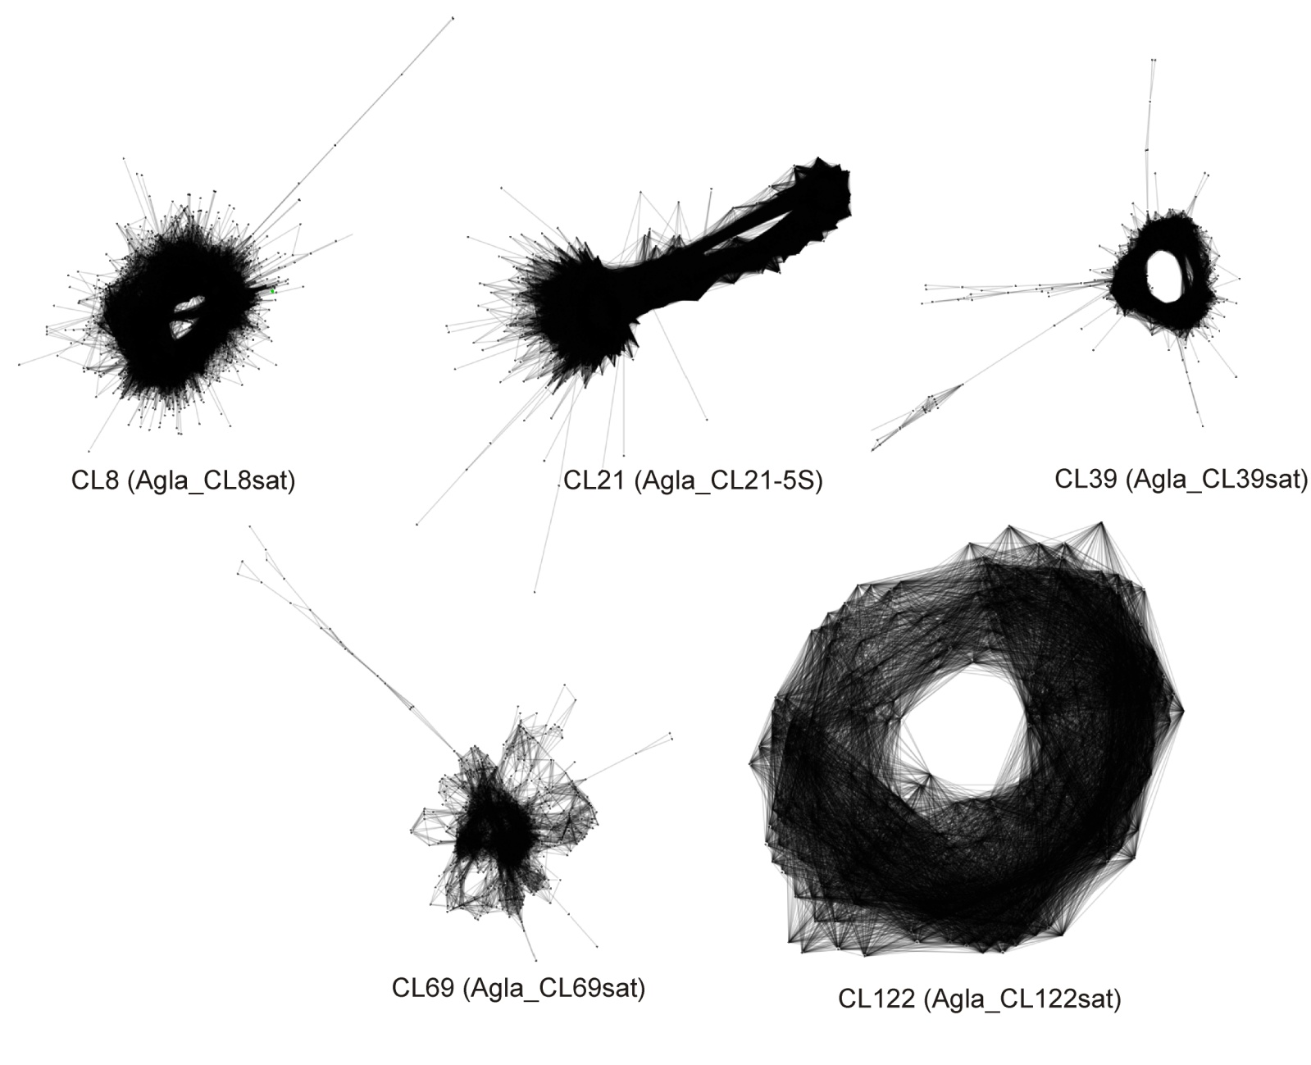
Suppl. Fig. S1 Graph layouts of read clusters containing tandem repeats in the genome of A. glandulifera. These graphs correspond to four satellite DNA sequences (Agla_CL8sat, Agla_CL39sat, Agla_CL69sat, and Agla_CL122sat) and the 5S rDNA (Agla_CL21-5S).

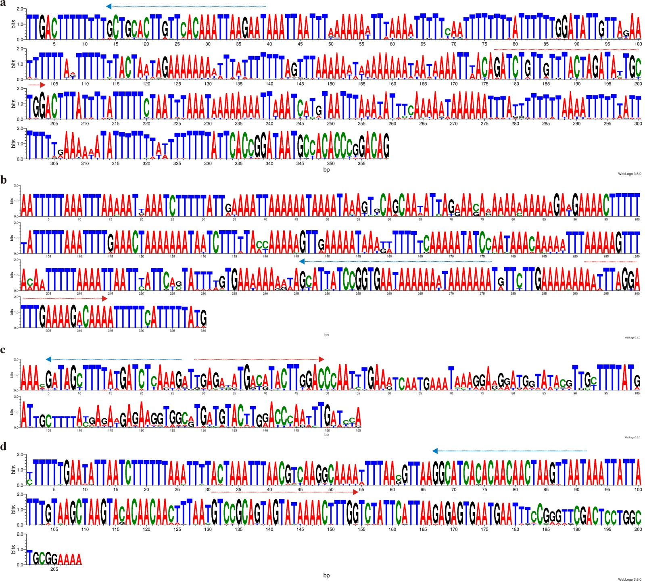
Suppl. Fig. S2 Logos of the repetitive units of the identified satDNAs: Agla_CL8sat (a), Agla_CL39sat (b), Agla_CL69sat (c) and Agla_CL122sat (d). The y-axis shows the probability of each residue for each position, whereas the x-axis indicates the position of each residue. Positions of the forward and reverse primers of the Table 1 are marked by red and blue arrows, respectively.

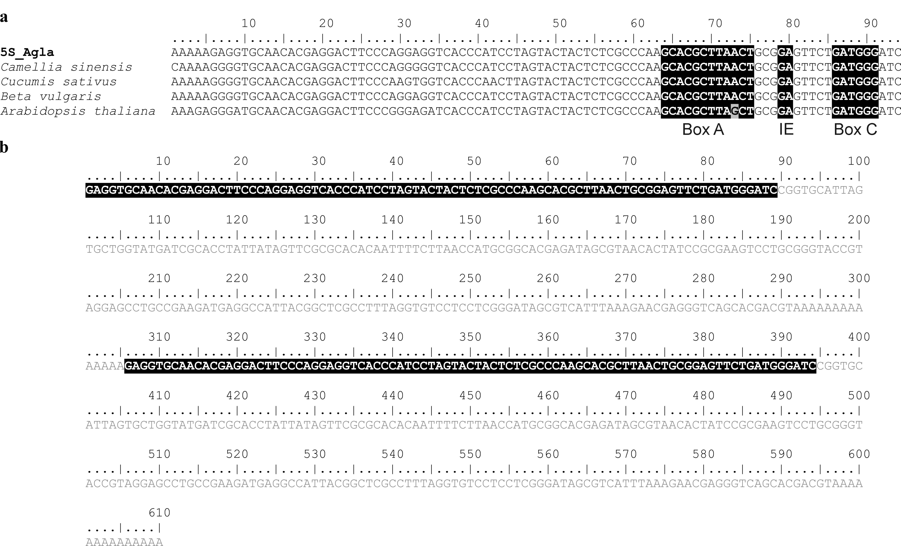
Suppl. Fig. S3 Alignment of 5S rRNAs from A. glandulifera and other plant species. a) The Agla_5S gene boundaries were derived from the alignment with other plant 5S rRNA genes: Camellia sinensis (AY101390), Cucumis sativus (KF543346), Beta vulgaris (Z25804) and Arabidopsis thaliana (AF198185). The region of the intragenic promotor, defined by the Box A, the Intermediate Element (IE), and the Box C (Cloix et al. 2000) are shaded. b) Dimer derived contig of Agla_CL21-5S. The coding regions are shaded while the intergenic spacers are in gray.

